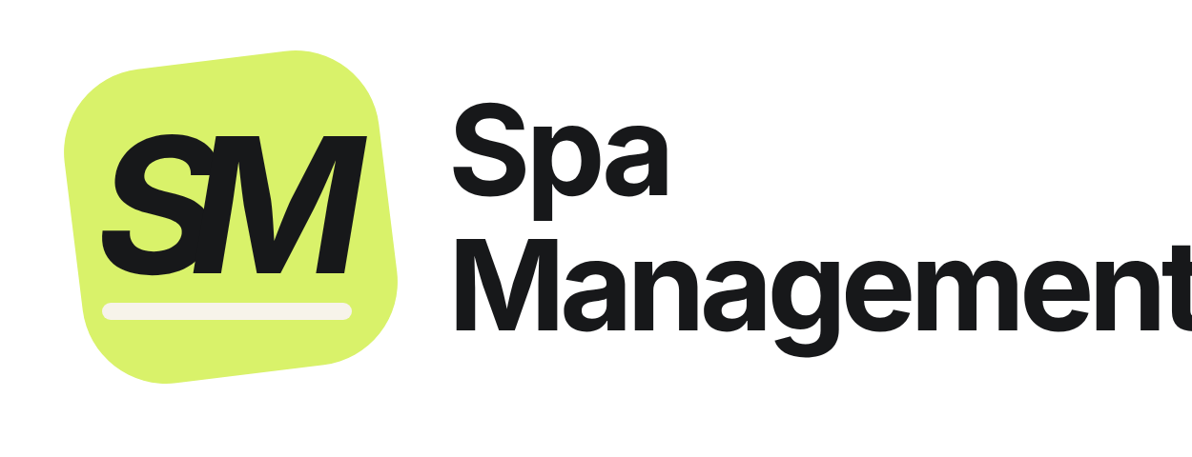  Powered by  | Spa Management  1997labs Tech Solutions  ask@spamanagement.co · 1997labs.com

Invoice
  Invoice no. | [SM-INV-2026-000]
  Date | [DD Mon YYYY]
  Due | [By 10 Mon YYYY]
  Currency | AED

BILL TO  [Spa legal name]  [Area, City], United Arab Emirates  Tel: [phone] · WhatsApp: [WhatsApp] |  | PLAN  [Premium] plan SPECIAL OFFER  [Spa name] gets every [Premium] feature at the [Standard] plan price, as a special offer from Spa Management.  Website: 2 languages, English + Arabic. CRM system: 2 languages, English + Thai.

Invoice details
Description | Qty | Unit price | Amount
[Premium] plan: monthly subscription  [Month YYYY] (1–[30] [Month]). Includes:  - Website (English + Arabic) and CRM system (English + Thai): secure cloud hosting, SSL certificate  - SEO care: page titles and descriptions, Google sitemap and structured data, Google Search Console, redirects from old links, weekly SEO health check  - Google Business Profile care: keeping your Google profile up to date (opening hours, phone, services, photos, website link) and maintained  - Support 7 days a week by WhatsApp and email; website text and price changes on request  - Daily backups and security updates, so your data is safe  - New features and system updates at no extra cost | 1 | [3,000.00] | [3,000.00]
SPECIAL OFFER [Premium at the Standard price] | 1 | [−1,000.00] | [−1,000.00]
Total due (AED) |  |  | [2,000.00]
You save AED [1,000] every month compared with the [Premium] list price.
Payment
- Payment by bank transfer, cash or card payment link.
- Must be paid by 10 [Month YYYY] at the latest.
- The monthly subscription of AED [2,000] is invoiced each month and due by the 10th of that month.
This is an official invoice issued by 1997labs Tech Solutions (Spa Management); no stamp or signature is needed.

